Deividas Rakauskas X00126600

Android/ASP.Net Core Web API CA2 Report

**Github** - <https://github.com/akantor333/EAD2CA2>

Contains folders for:

1. WebApplication2: The ASP NET Core API
2. AndroidApp: The android studio development files
3. APK: keystore folder and a signed built apk

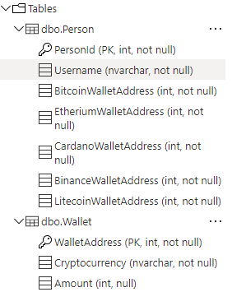**Database Schema**

Contains 2 tables, Person to store the users and Wallet to store the wallets. Each person has 5 wallets for each cryptocurrency.

**Service**

short description of operations, screen shot of swagger UI test page, how it has been deployed e.g. Azure app service settings

Provides 3 API get methods:

1. Get all persons
2. Get single person by id
3. Get all persons matching query string (search)

It has been deployed as an azure API within Azures App Services. It is managed under Azure API Management and requires a subscription key to access the api. Azures settings include cheapest/free plan, West Europe hosted servers and database

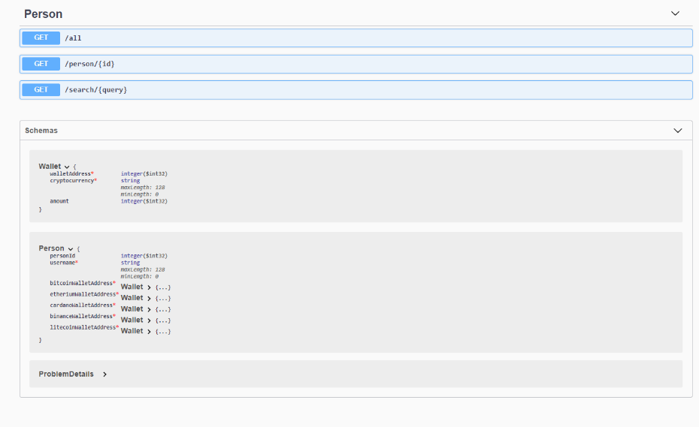

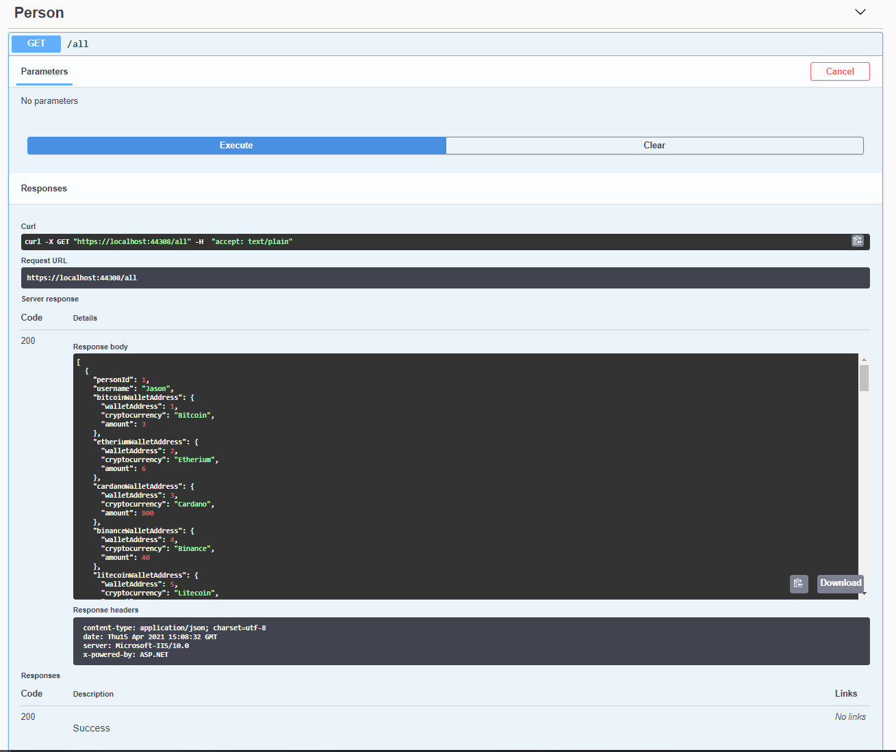

**App**

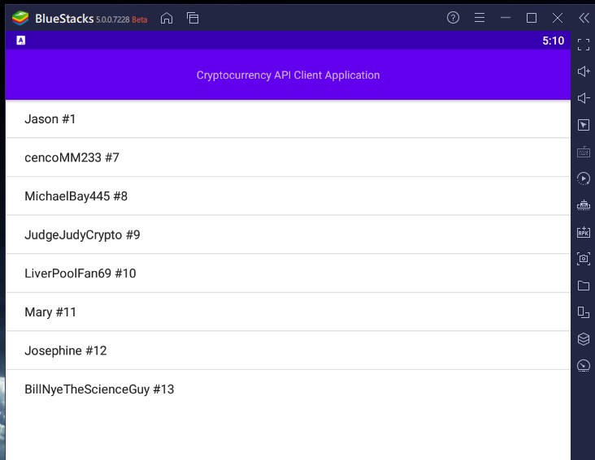

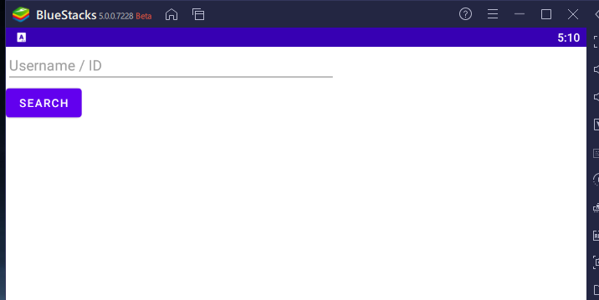

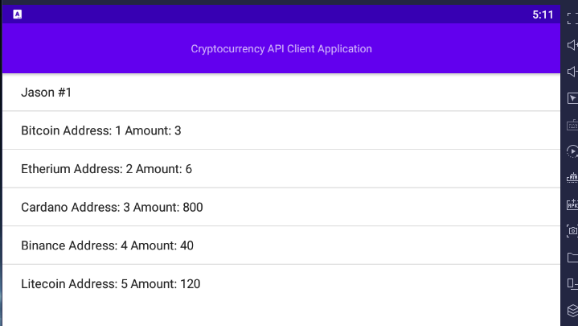

Application developed in Android Studios lists all users by default using the getall api call. Allows users to click on each entry to view the wallet data associated. Allows the user to search for a person with a query string either by name or by id.

Application is internationalised to the Lithuanian language and each string is translated.

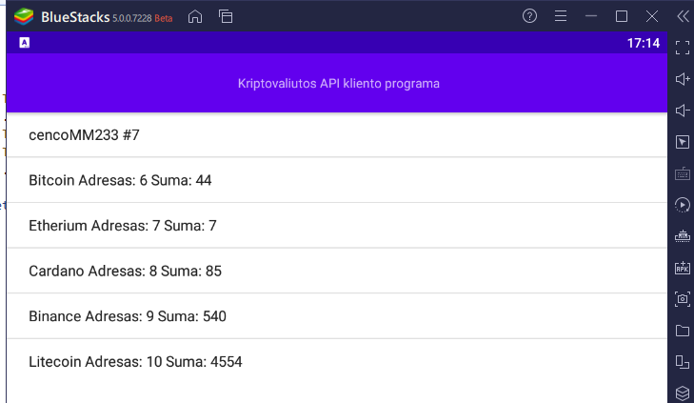

**Miscellaneous**

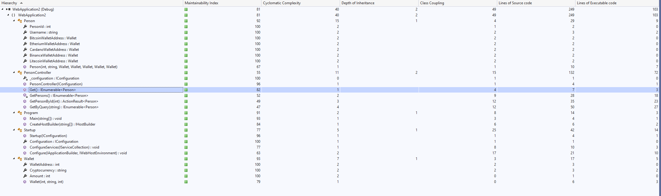

Code analysis mostly comes up good apart from PersonController which scores low on the get methods where the database is accessed. I definitely could improve in coding when it comes to error handling and general database requests.